**ANSWERS TO OBJECTIVE & SUBJECTIVE QUESTIONS**

**Table to represent the number of restaurants opened in each country.**

Below shown table shows the total number of restaurants in each country and i used pivot table to summarize the answer.

|  |  |
| --- | --- |
| **Country** | **Number of Restaurants** |
| Australia | 24 |
| Brazil | 60 |
| Canada | 4 |
| India | 8652 |
| Indonesia | 21 |
| New Zealand | 40 |
| Philippines | 22 |
| Qatar | 20 |
| Singapore | 20 |
| South Africa | 60 |
| Sri Lanka | 20 |
| Turkey | 34 |
| United Arab Emirates | 60 |
| United Kingdom | 80 |
| United States of America | 425 |
| **Grand Total** | **9542** |

**Number of restaurants opened each year.**

Below table shows the number of Restaurants opened in each year.

|  |  |
| --- | --- |
| **Year of Opening** | **Number of Restaurants** |
| 2010 | 1079 |
| 2011 | 1096 |
| 2012 | 1022 |
| 2013 | 1059 |
| 2014 | 1049 |
| 2015 | 1023 |
| 2016 | 1026 |
| 2017 | 1086 |
| 2018 | 1102 |
| **Grand Total** | **9542** |

**What is the total number of restaurants in India which are in the price range 4?**

There are a total of 388 restaurants in India which are in the price range of 4. I created the Pivot table and filtered the data accordingly to get this number of 388 restaurants. In Excel file under the Pivots & Charts sheet I have done the filtration.

|  |
| --- |
| **Total number of Restaurants in India with Price Range - 4** |
| **388** |

**Average number of voters for the restaurants in each country according to the data.**

|  |  |
| --- | --- |
| AVERAGE NUMBER OF VOTERS | |
| **Country** | **Average of Votes** |
| Australia | 111.4 |
| Brazil | 19.6 |
| Canada | 103 |
| India | 137.2 |
| Indonesia | 772.1 |
| New Zealand | 243.0 |
| Philippines | 407.4 |
| Qatar | 163.8 |
| Singapore | 31.9 |
| South Africa | 315.2 |
| Sri Lanka | 146.5 |
| Turkey | 431.5 |
| United Arab Emirates | 493.5 |
| United Kingdom | 205.5 |
| United States of America | 430.9 |
| **Grand Total** | **156.8** |

**Suggest few countries where the team can open newer restaurants with lesser competition.**

1. Canada
2. Indonesia
3. Qatar
4. Turkey

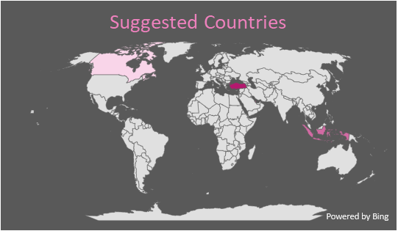

I have created a Pivot Table from the given dataset with two variables Country and Count of Restaurant ID. Countries with fewer restaurants means there is less competition to open a new restaurant. Also, we can introduce new cuisines in these restaurants where people can come and try new food. I have used Map chart to show the countries I have chosen to open restaurants.

**Come up with the names of Cities in the suggested countries suitable for opening restaurants.**

|  |  |
| --- | --- |
| **City** | **Number of Restaurants** |
| Bandung | 1 |
| Bogor | 2 |
| Chatham-Kent | 1 |
| Consort | 1 |
| Doha | 20 |
| Tangerang | 2 |
| Vineland Station | 1 |
| Yorkton | 1 |
| ÛÁstanbul | 14 |
| **Grand Total** | **43** |

These are the name of cities where we can open restaurants in the suggested countries. I used Pivot table to filter the data and used count function for RestaurantID to get the numbers. In the above mentioned cities, there are lesser competitors and Doha is the only city in Qatar so I picked that city as we can see it is a famous city with more restaurants.

**According to the countries you suggested, what is the current quality in terms of ratings for restaurants that are opened there?**

With the use of Pivot Table and Average Aggregation Function, the current quality in terms of ratings is 4.2 for all the restaurants opened there.

|  |  |
| --- | --- |
| **Country** | **Average of Rating** |
| Canada | 3.6 |
| Indonesia | 4.3 |
| Qatar | 4.1 |
| Turkey | 4.3 |
| **Grand Total** | **4.2** |

**Also, what is the current expenditure on the food in the suggested countries, so that we can keep our financial expenditure in control?**

To answer this question, first I used a Pivot Table with country and Average cost for two people. Second , I applied the average function for that variable in the table. As we can see in the above shown table, expenditure for two people is $36.25 in Canada and so on for the remaining countries.

|  |  |
| --- | --- |
| **Country** | **Average_Cost_for_two** |
| Canada | $36.25 |
| Indonesia | Rp281,190.48 |
| Qatar | 223.75 ر.ق.‏ |
| Turkey | ₺84.85 |

**Come up with the names of restaurants from the recommended states who are our biggest competitors and also those which are rated in the lower brackets, i.e. 1-2 or 2-3.**

To identify who are our biggest competitors, we can use variable “Rating” and “Restaurant Name” to filter and find out the competitors in our selected countries. Restaurants with highest ratings can become our competitors (for this I have considered restaurants having a rating of 4.5 and above). There are no restaurants with lower brackets in the suggested countries.

Below are the findings of the biggest competitors in Canada, Turkey, Qatar and Indonesia with ratings 4.5 and above.

|  |
| --- |
| **Restaurant Name** |
| Draft Gastro Pub |
| Gymkhana |
| Mainland China Restaurant |
| Zaffran Dining Experience |
| Paper Moon |
| Meôhur í_zí_elik Aspava |
| Karakí_y Gí_llí_oÛôlu |
| J'adore Chocolatier |
| Dem Karakí_y |
| Pizza ÛÁl Forno |
| Starbucks |
| Talaga Sampireun |
| Sushi Masa |
| Talaga Sampireun |
| Hattena Hatay SofrasÛ± |
| Union Deli |
| Meôhur TavacÛ± Recep Usta |
| Talaga Sampireun |
| Toodz House |
| Gaga Manjero |
| Satoo - Hotel Shangri-La |

**According to our current data, should we go for online delivery and table booking? Does that affect the customer’s ratings?**

To answer this question, I used AVERAGEIFS function to check the ratings of restaurants who are delivering online and taking online bookings. And also repeated the same process to check the ratings if they don’t use online delivery and bookings. As we can see in the below shown Bar chart, average rating for Restaurants with Online delivery and Table booking have higher rating than the other. So, its better to go for Online delivery and Table booking to get better rating as the ratings proportionately affected.

**Should the team keep the rate of cuisines higher? Will that affect the feedback? According to our data are the rate of cuisines and ratings, correlated?**

|  |
| --- |
| Correlation between Rate of Cuisines and Ratings |
| 0.251833237 |

As we can see there is a positive correlation between Rate of Cuisines and Ratings which tells in our data the rate of cuisines and reatings are correlated slightly. Syntax =CORREL('Raw Data'!T2:T9543,'Raw Data'!W2:W9543).

* **What is the distribution of number of restaurants of different price ranges in all the countries?**

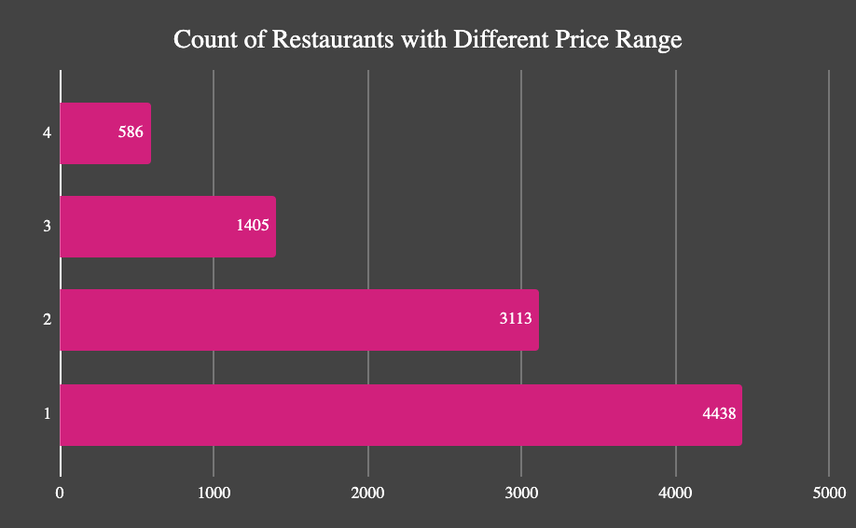

As we can see in the above table, the total number of restaurants with different price range from 1 to 4 in all the countries.